**SPRINT 1:**

| Task | Estimate | Day 1 | Day 2 | Day 3 | Day 4 | Day 5 | Day 6 | Day 7 | Day8 | Day 9 | Total |
| --- | --- | --- | --- | --- | --- | --- | --- | --- | --- | --- | --- |
| 1 | M | 3 | 2 | 0 | 0 | 2 | 1 | 4 | 4 | 0 | 16 |
| 2 | XS | 0 | 0 | 2 | 1 | 0 | 0 | 0 | 0 | 0 | 3 |
| 3 | M | 0 | 2 | 1 | 0 | 0 | 0 | 0 | 2 | 0 | 5 |
| 4 | M | 3 | 2 | 0 | 0 | 0 | 1 | 2 | 2 | 0 | 10 |
| 5 | M | 2 | 0 | 0 | 0 | 0 | 0 | 0 | 0 | 0 | 2 |

|  |  | Day 1 | Day 2 | Day 3 | Day 4 | Day 5 | Day 6 | Day 7 | Day 8 | Day 9 |
| --- | --- | --- | --- | --- | --- | --- | --- | --- | --- | --- |
| Actual Effort | 36 | 28 | 22 | 19 | 18 | 16 | 14 | 8 | 0 | 0 |
| Remaining Effort | 36 | 32 | 28 | 24 | 20 | 16 | 12 | 8 | 4 | 0 |

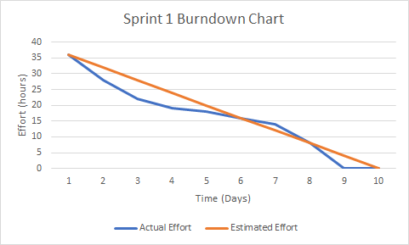

**SPRINT 2:**

| Task | Estimate | Day 1 | Day 2 | Day 3 | Day 4 | Day 5 | Day 6 | Day 7 | Day8 | Day 9 | Total |
| --- | --- | --- | --- | --- | --- | --- | --- | --- | --- | --- | --- |
| 1 | M | 2 | 0 | 0 | 0 | 0 | 0 | 0 | 0 | 0 | 2 |
| 2 | L | 2 | 1 | 0 | 0 | 0 | 0 | 0 | 0 | 0 | 3 |
| 3 | XL | 0 | 2 | 0 | 0 | 2 | 2 | 0 | 0 | 3 | 9 |
| 4 | L | 0 | 0 | 0 | 3 | 5 | 0 | 0 | 0 | 0 | 8 |
| 5 | S | 0 | 0 | 0 | 0 | 2 | 0 | 0 | 1 | 0 | 3 |
| 6 | XS | 0 | 0 | 0 | 0 | 0 | 0 | 0 | 0 | 1 | 1 |
| 7 | S | 0 | 0 | 0 | 0 | 0 | 0 | 0 | 0 | 2 | 2 |

|  |  | Day 1 | Day 2 | Day 3 | Day 4 | Day 5 | Day 6 | Day 7 | Day 8 | Day 9 |
| --- | --- | --- | --- | --- | --- | --- | --- | --- | --- | --- |
| Actual Effort | 28 | 24 | 21 | 21 | 18 | 9 | 7 | 7 | 6 | 0 |
| Remaining Effort | 28 | 24 | 21 | 18 | 15 | 12 | 9 | 6 | 3 | 0 |

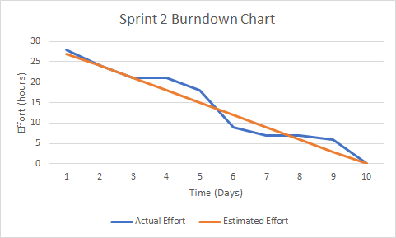

**SPRINT 3:**

| Task | Estimate | Day 1 | Day 2 | Day 3 | Day 4 | Day 5 | Day 6 | Day 7 | Day8 | Day 9 | Total |
| --- | --- | --- | --- | --- | --- | --- | --- | --- | --- | --- | --- |
| 1 | M | 0 | 1 | 3 | 3 | 2 | 0 | 0 | 0 | 0 | 9 |
| 2 | S | 0 | 0 | 2 | 2 | 0 | 0 | 0 | 0 | 0 | 4 |
| 3 | S | 0 | 0 | 0 | 0 | 2 | 2 | 0 | 0 | 0 | 4 |
| 4 | M | 0 | 0 | 0 | 2 | 3 | 0 | 0 | 0 | 0 | 5 |
| 5 | L | 0 | 2 | 1 | 1 | 0 | 1 | 0 | 1 | 0 | 6 |
| 6 | M | 0 | 0 | 0 | 0 | 0 | 0 | 0 | 0 | 5 | 5 |

|  |  | Day 1 | Day 2 | Day 3 | Day 4 | Day 5 | Day 6 | Day 7 | Day 8 | Day 9 |
| --- | --- | --- | --- | --- | --- | --- | --- | --- | --- | --- |
| Actual Effort | 33 | 33 | 30 | 24 | 16 | 9 | 6 | 6 | 5 | 0 |
| Remaining Effort | 33 | 29 | 26 | 22 | 18 | 14 | 10 | 6 | 3 | 0 |

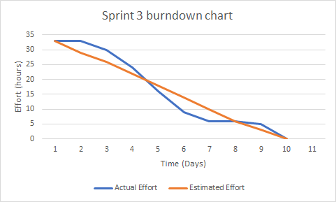

**SCALING SYSTEM:**

XS - Less than an hour

S - A few hours

M - A day or so

L - A week or so

XL - More than a week